3. Git-HOL:
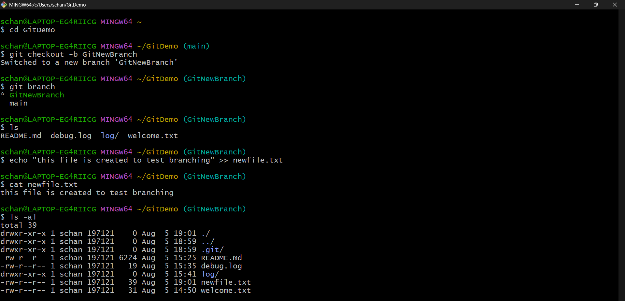
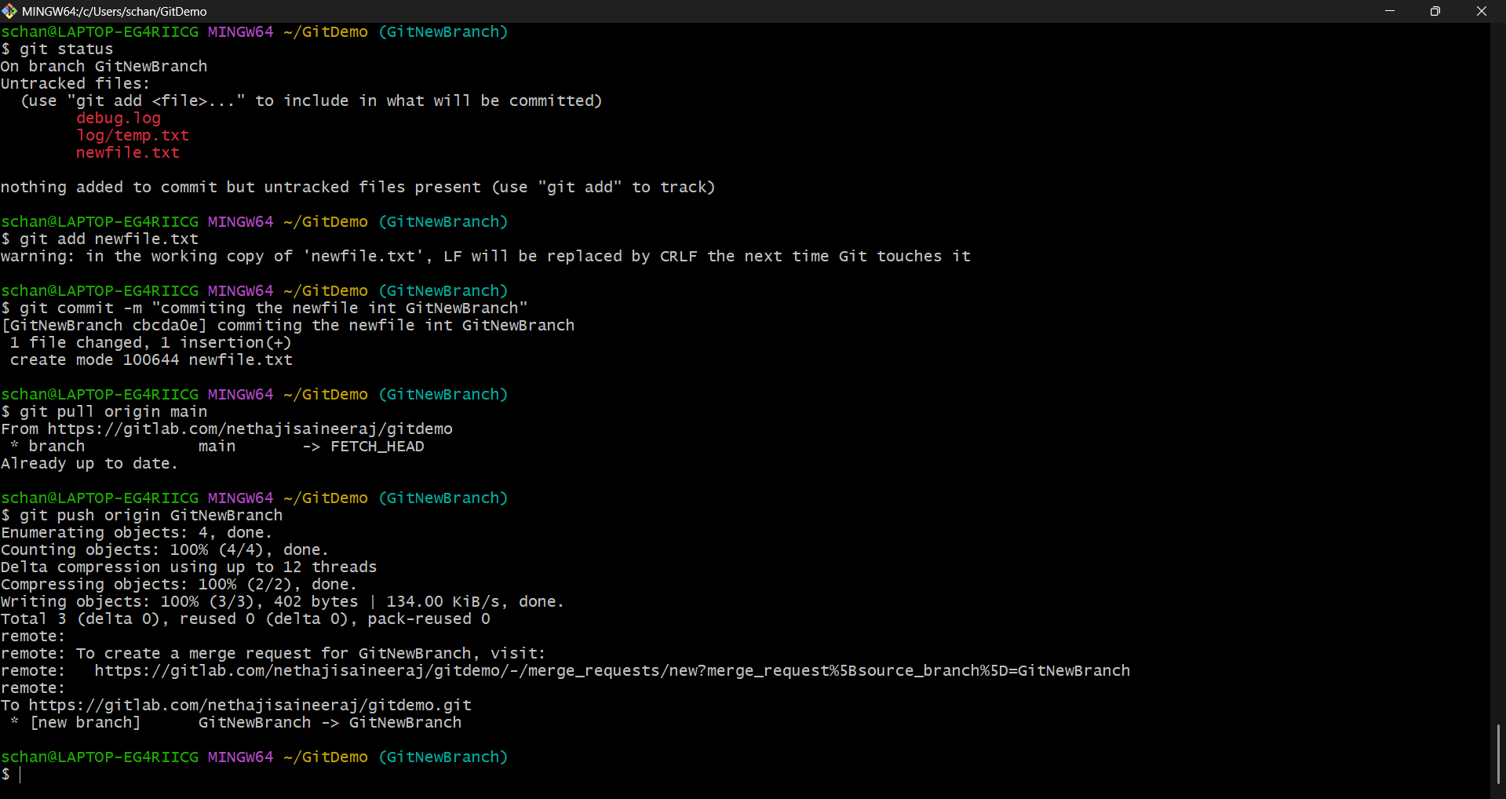
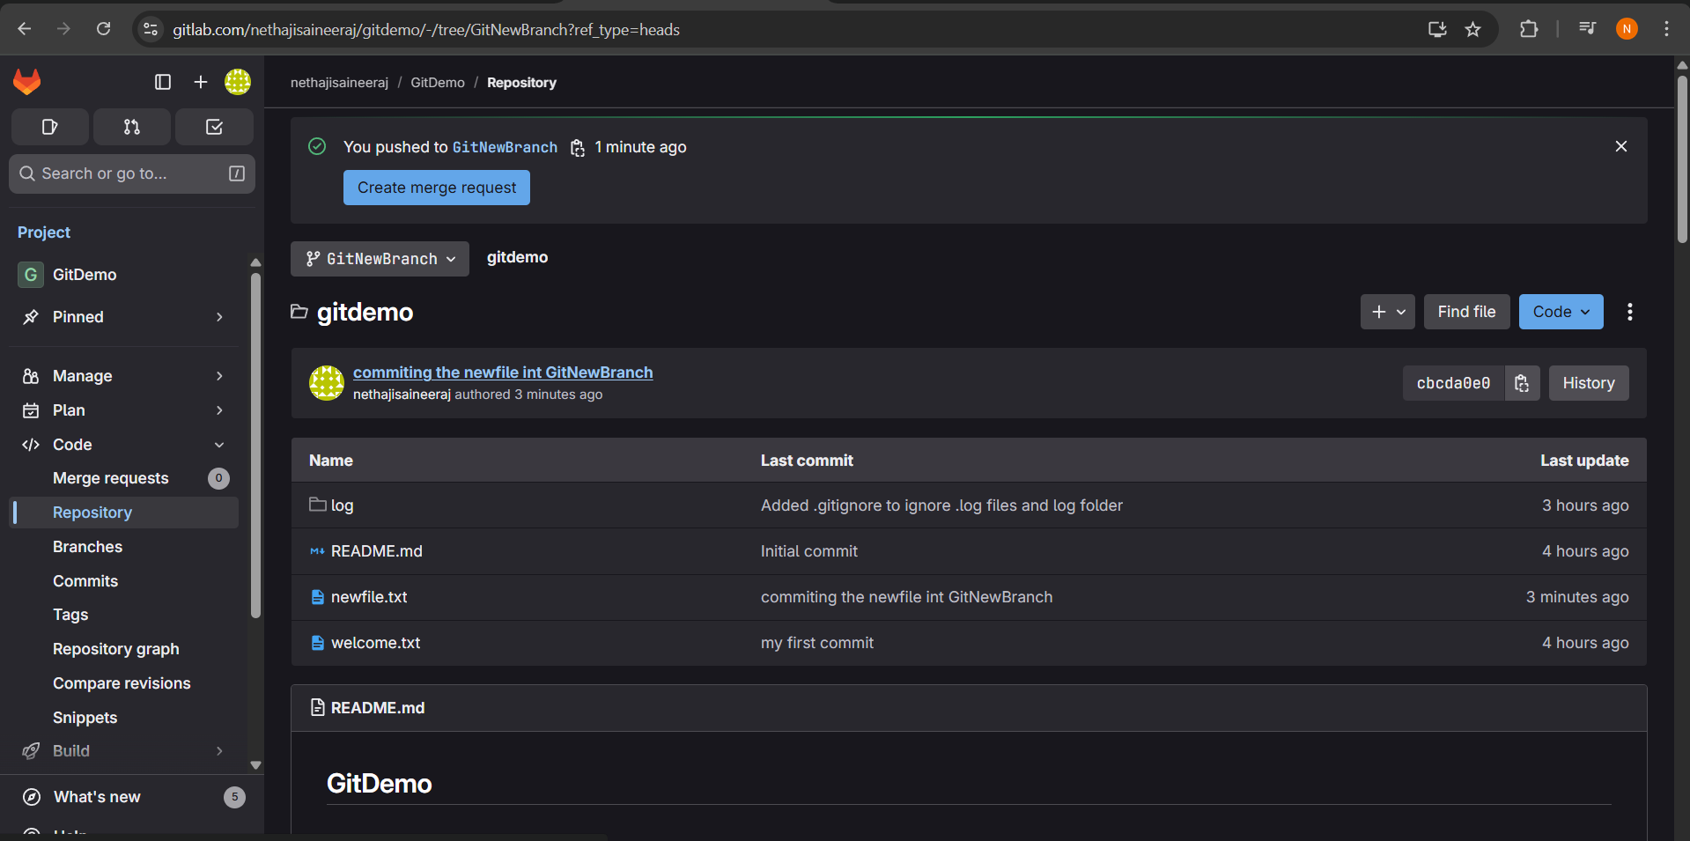
Checking out the difference
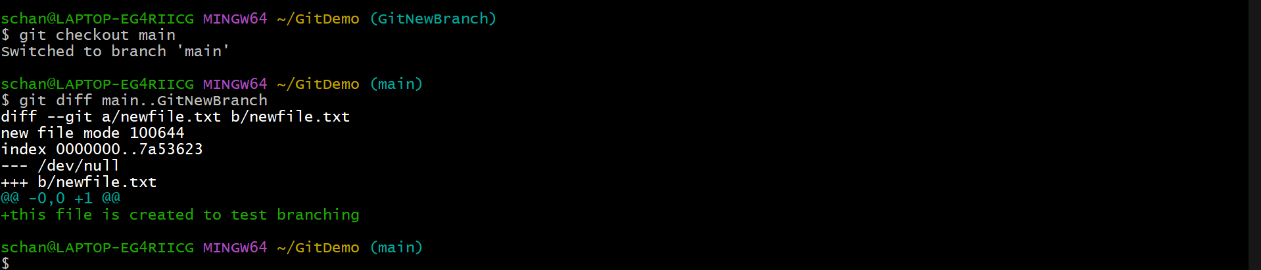
P4merge tool:
Downloaded the p4merge tool from browser
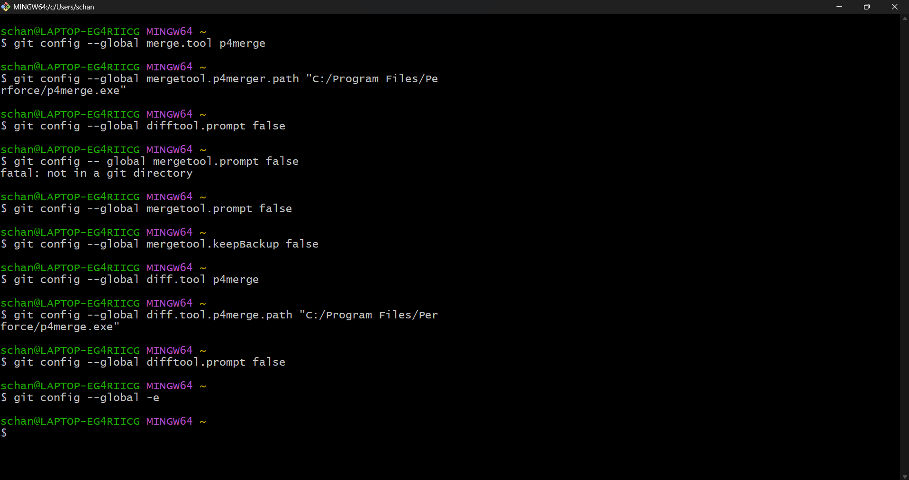
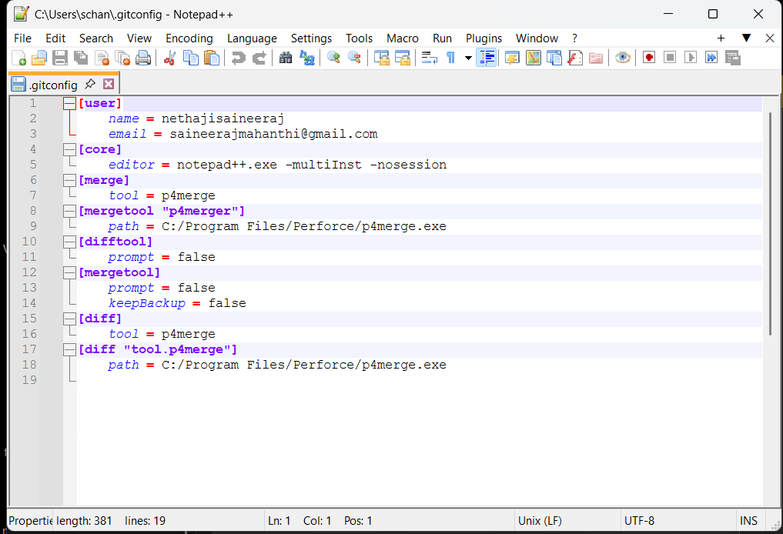
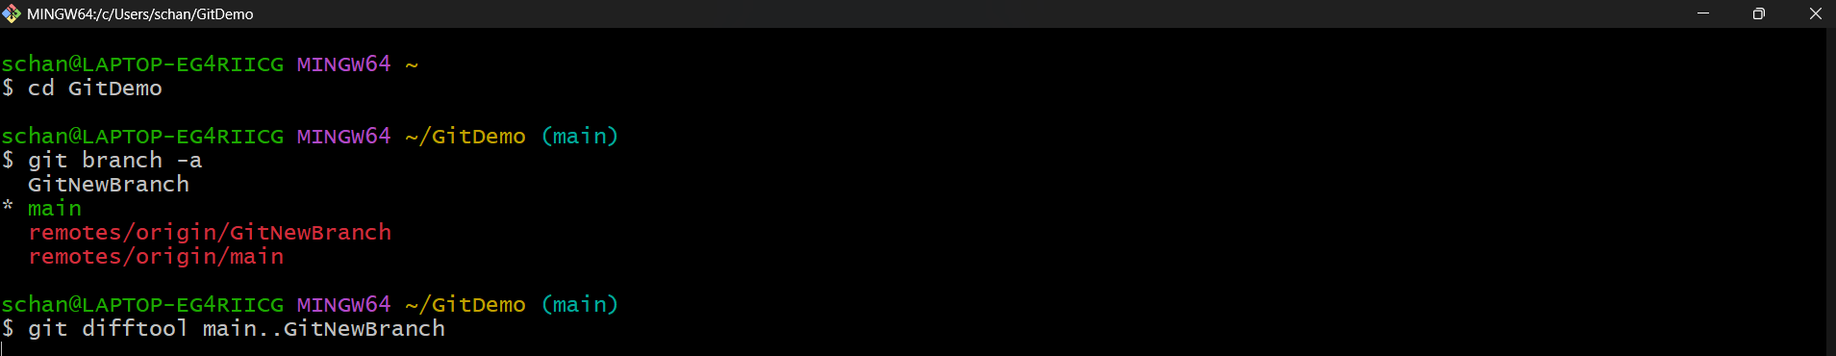
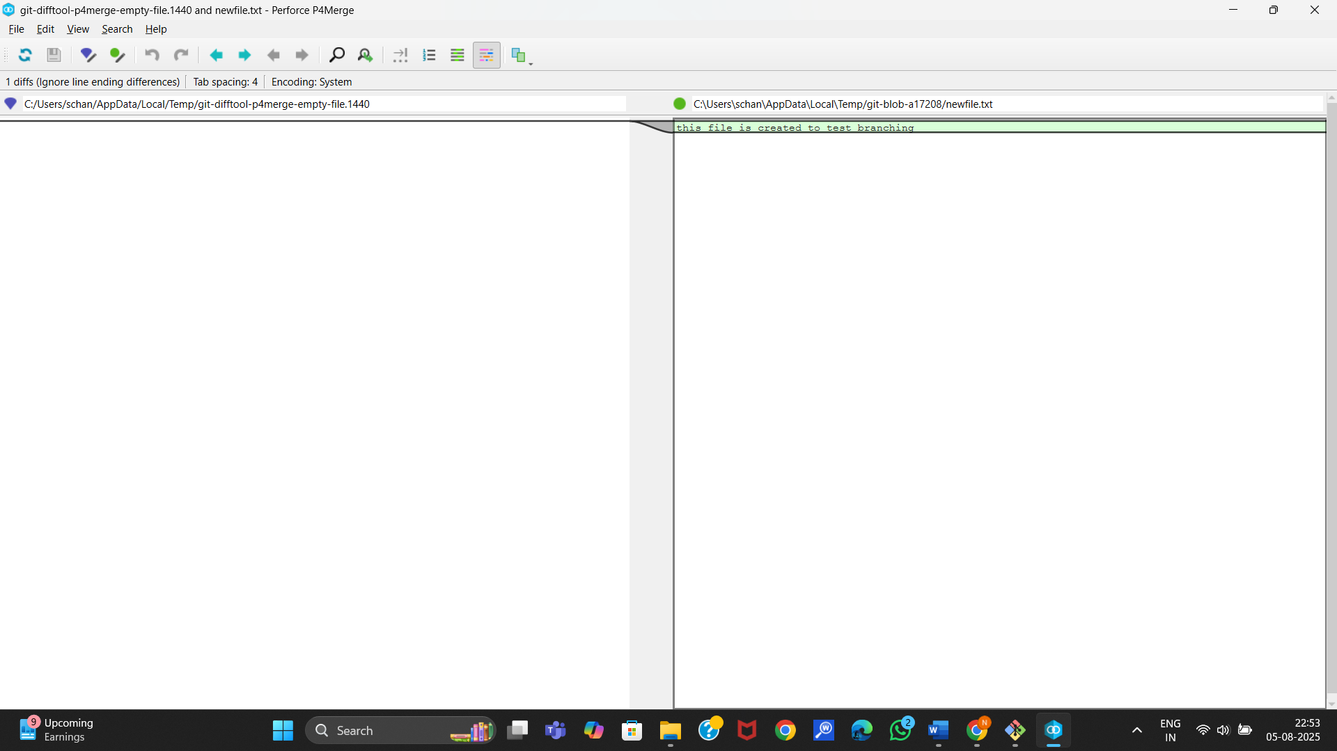

Now merge new branch and main branch
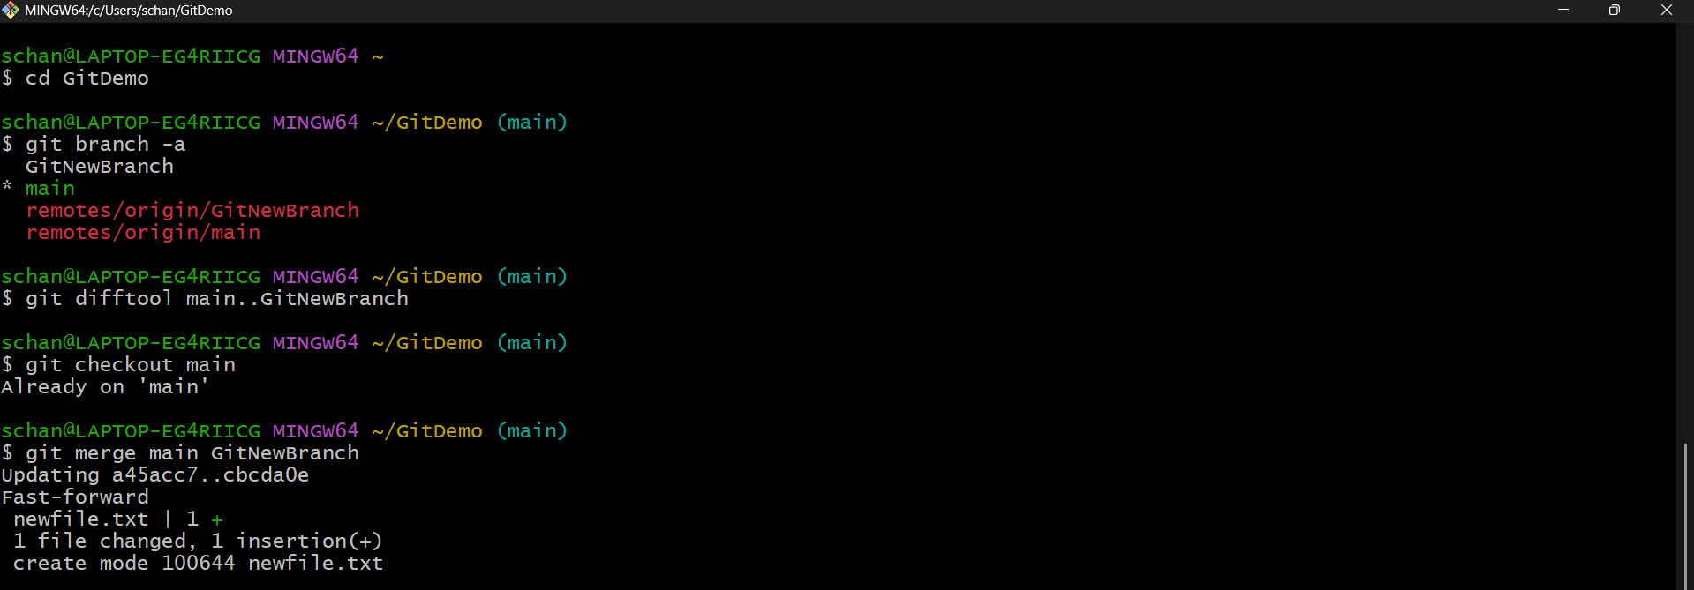
Git log command
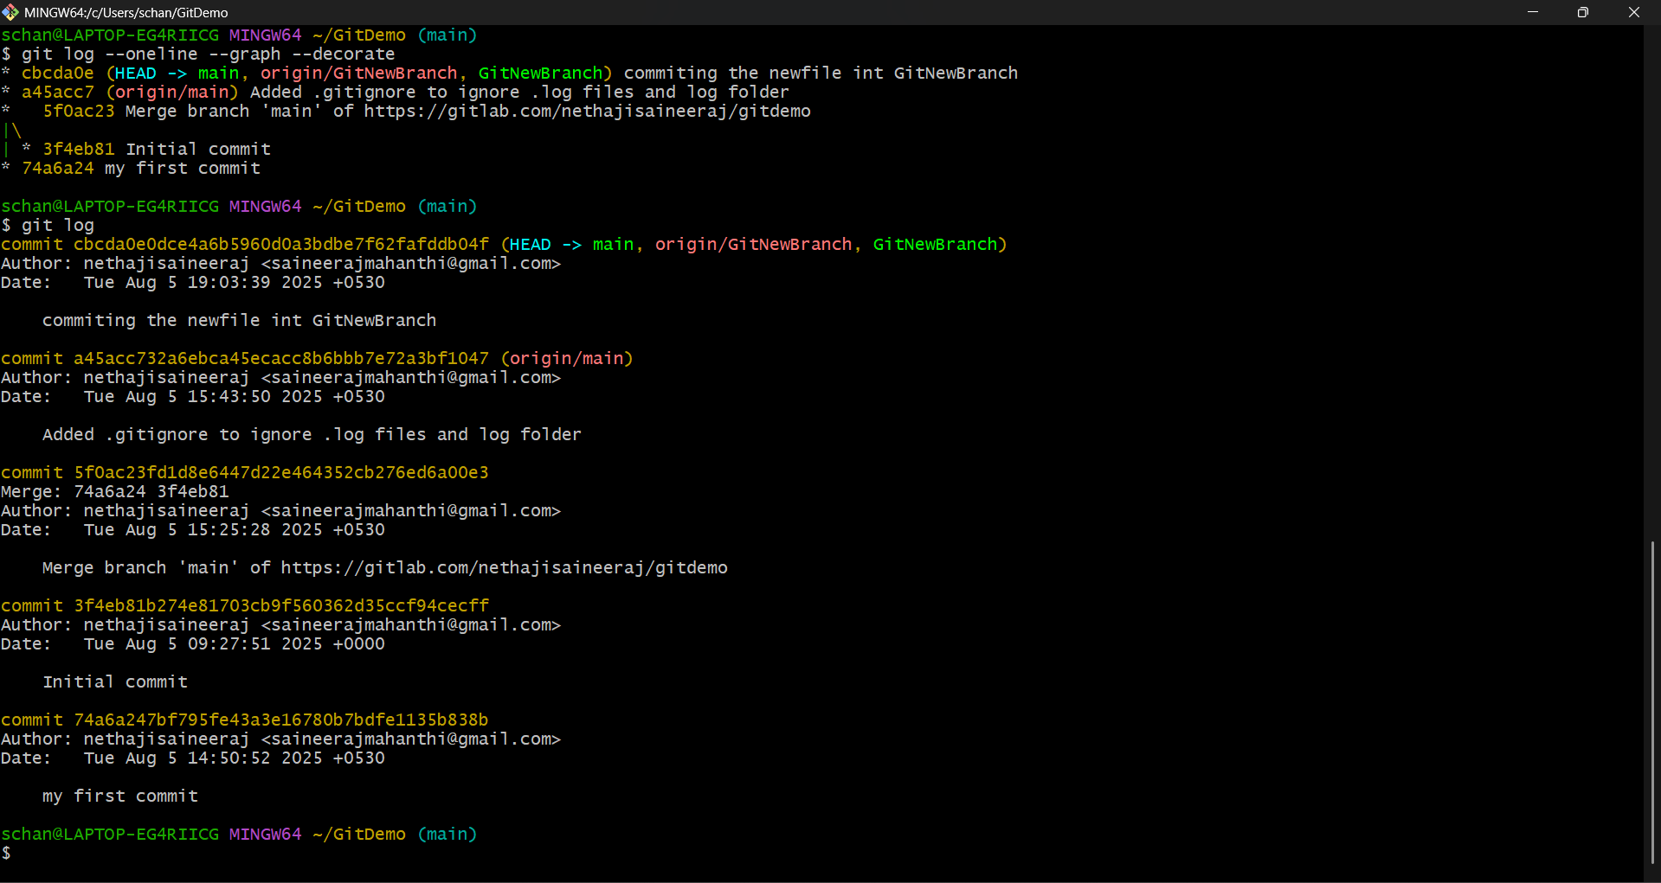
To reflect the changes in the remote repo as well we need to push it
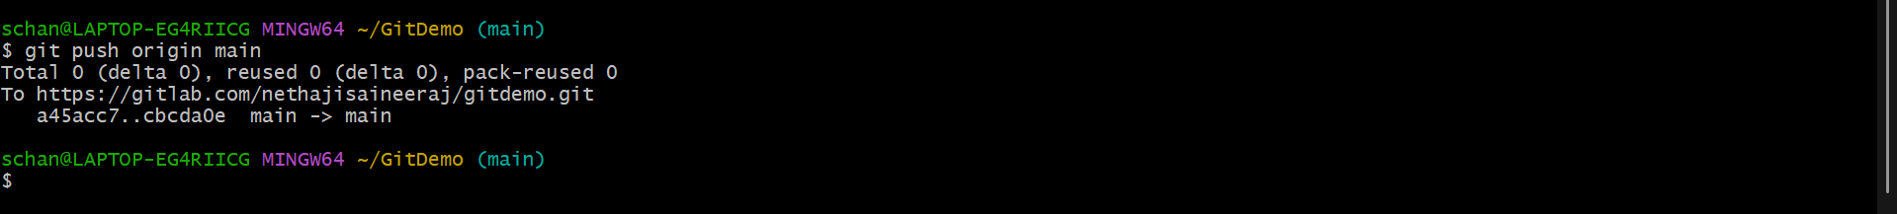
Git lab
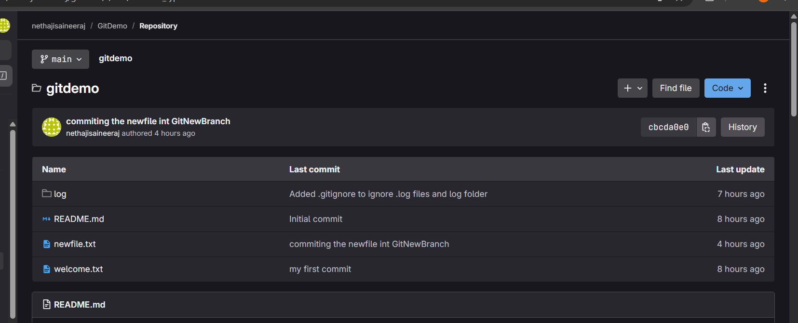
Previously the newfile.txt is not there in the main branch it came from GitNewBranch after merging.
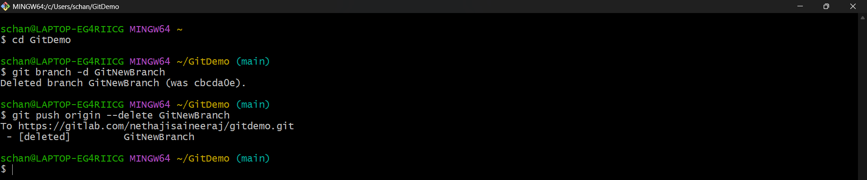
In the git lab also the branch is deleted
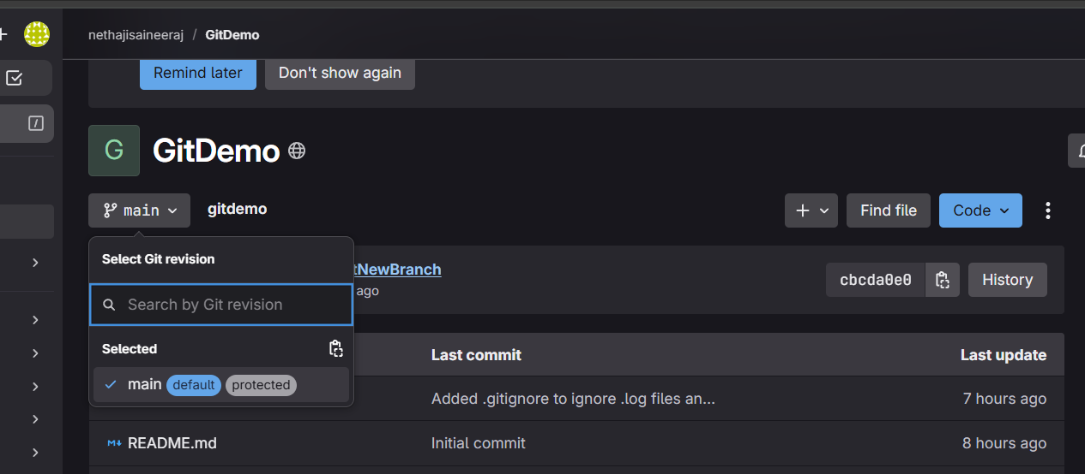
Note: those untracked files are from gitignore HOL.

